42.43: 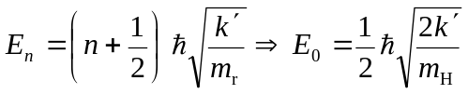
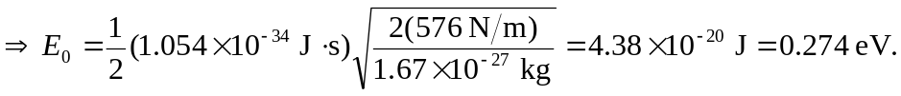
This is much less than the 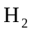bond energy.

